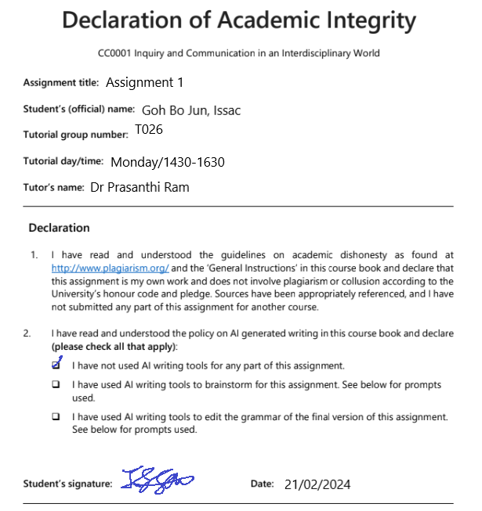

Tucked away in a corner of Singapore sits a small Japanese inspired climbing gym, Boruda. As I stepped into the gym, the cool breeze of the air conditioning danced around me, relieving me of the afternoon heat I braved to get to the gym. I was greeted by a plethora of colourful climbing holds snaking up the bland wooden walls. The chalked filled air seemingly impeded my vision, reminding me of the annual haze. As my sense of hearing heightens to compensate for my reduced visibility, audible cheers could be heard coming from the cluster of people gathered near the crash pads beneath the walls. Adorned in her national jersey with a bolded word of “Singapore”, a national climber reaches into her chalk bag, swiftly coating her hands in the fine white powder. With a swift recovery, fueled by the crowd’s support and the friction of the chalk, she presses on.

Lined along another side of the gym was a row of plain wooden benches and tables, presently occupied by adults in their early 20s. Their brows are furrowed in deep concentration as they furiously type away at their laptop, presumably for their work or studies. One would assume that they came here solely to work in an air-conditioned environment. Yet, on the contrary, their climbing shoes remain tightly laced, showcasing their unwillingness to be off the wall. The silence was deafening and painfully obvious compared to the mere two metres away gap where climbers' cheers filled the room as someone was making their way up the wall. The adults' poor hunched up posture while working was made even more apparent when contrasting with some of the climbers blatantly lounging on the floor as if it were their own home. Such a scene highlighted a difference I neglected at the pigeonhole area to store personal belongings where a sea of backpacks with dedicated laptop compartments seem to be the majority. This is a sharp contrast with other sports where duffel bags reigned supreme with its tailored functions for sports related activities.

It seemed baffling to observe individuals being engrossed in their work while surrounded by an environment intended for recreation. I held the belief that recreational activities serve as a gateway to help participants to break free from the working environment and unwind from their worries. Yet, climbers can be seen voluntarily blending the two realms, climbing the corporate ladder instead of the walls provided.This suggests a conscious choice by the adults to remain well-connected with their work even during down time. Furthermore, since it was a weekend, it reduces the chance that they were working remotely, implying that their actions were voluntary rather than obligatory. I believe that such a sight could not have been due to mere chance alone and highlights the fact that they came in with the intention of not just climbing but working. The presence of signs denoting that meals were restricted to the tables showcases that the climbers have thus repurposed the subspace consciously, seemingly due to their inability to break free from the clasp of the working world. This phenomenon of working adults converting recreational spaces into work spaces prompts the question, why do individuals in Singapore tend to integrate work and leisure in unconventional spaces?

Word count: 544